Name: ASHIKA IMRANA.A

Project Title: CREATING AN SPONSERED POST FOR INSTAGRAM

DEPARTMENT: COMPUTER SCIENCE AND ENGINEERING

COURSE DETAIL: DIGITAL MARKETING

COLLEGE: DHANALAKSHMI SRINIVASAN INSTITUTE OF TECHNOLOGY

NM ID: ABEB59E119793E0B2424A5496C00B939

ZONE: 12

ABSTRACT:

ADP Boutique is a unique and chic boutique shop that offers a curated selection of fashion, accessories, and lifestyle products. This boutique caters to the fashion-forward individual seeking exclusive, handpicked items. With a keen eye for style and quality, ADP Boutique provides a personalized shopping experience, blending modern trends with timeless classics. Explore a world of elegance and sophistication at ADP Boutique, where every visit promises to be a delightful journey through fashion and aesthetics.

Step 1: Login into canva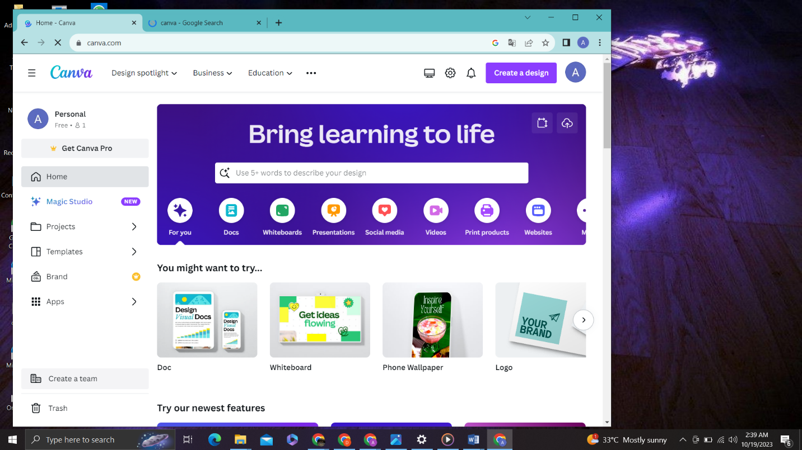

Step 2: Design a social media poster using canva

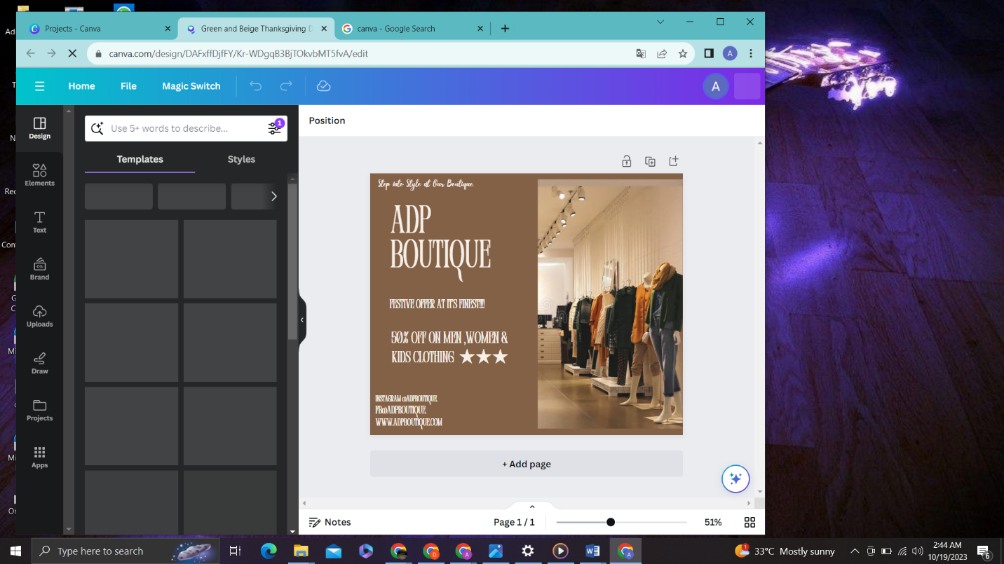

Step 3: Login into Instagaram

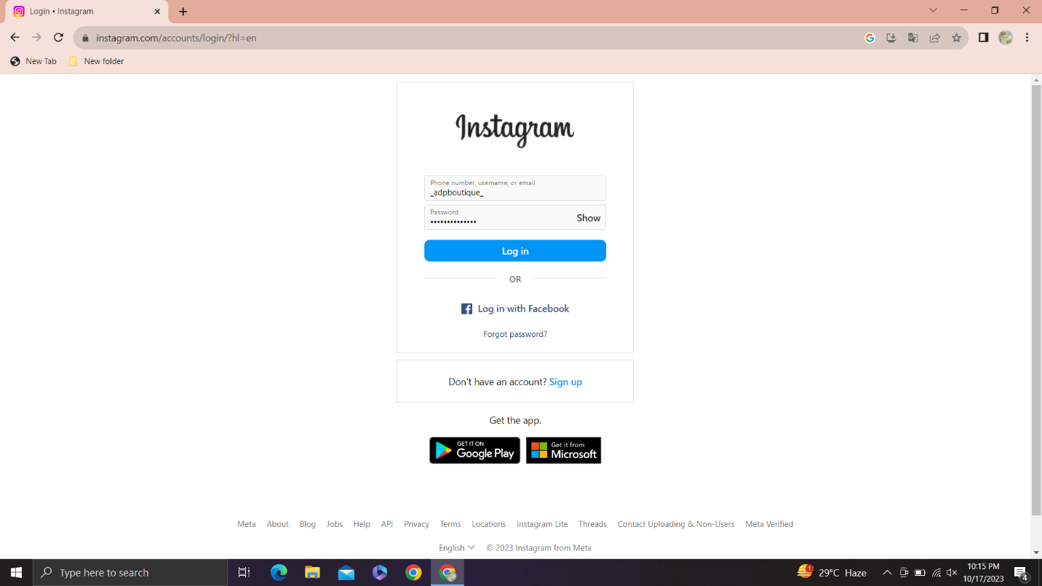

Step 4: Create a professional account in Iinstagram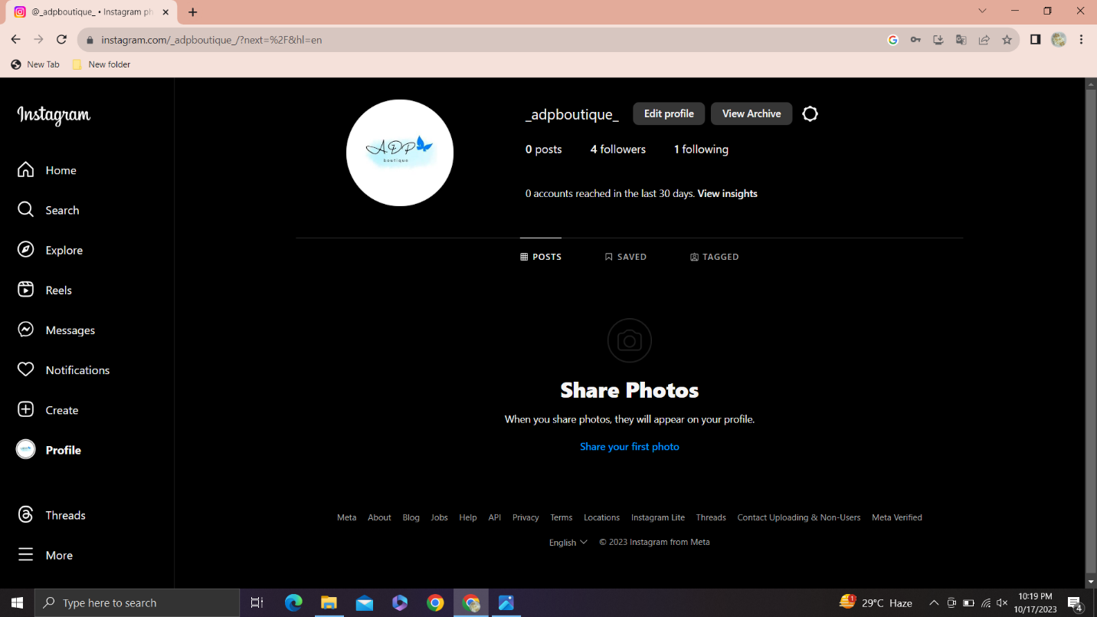

Step 5: Post your design in Instagram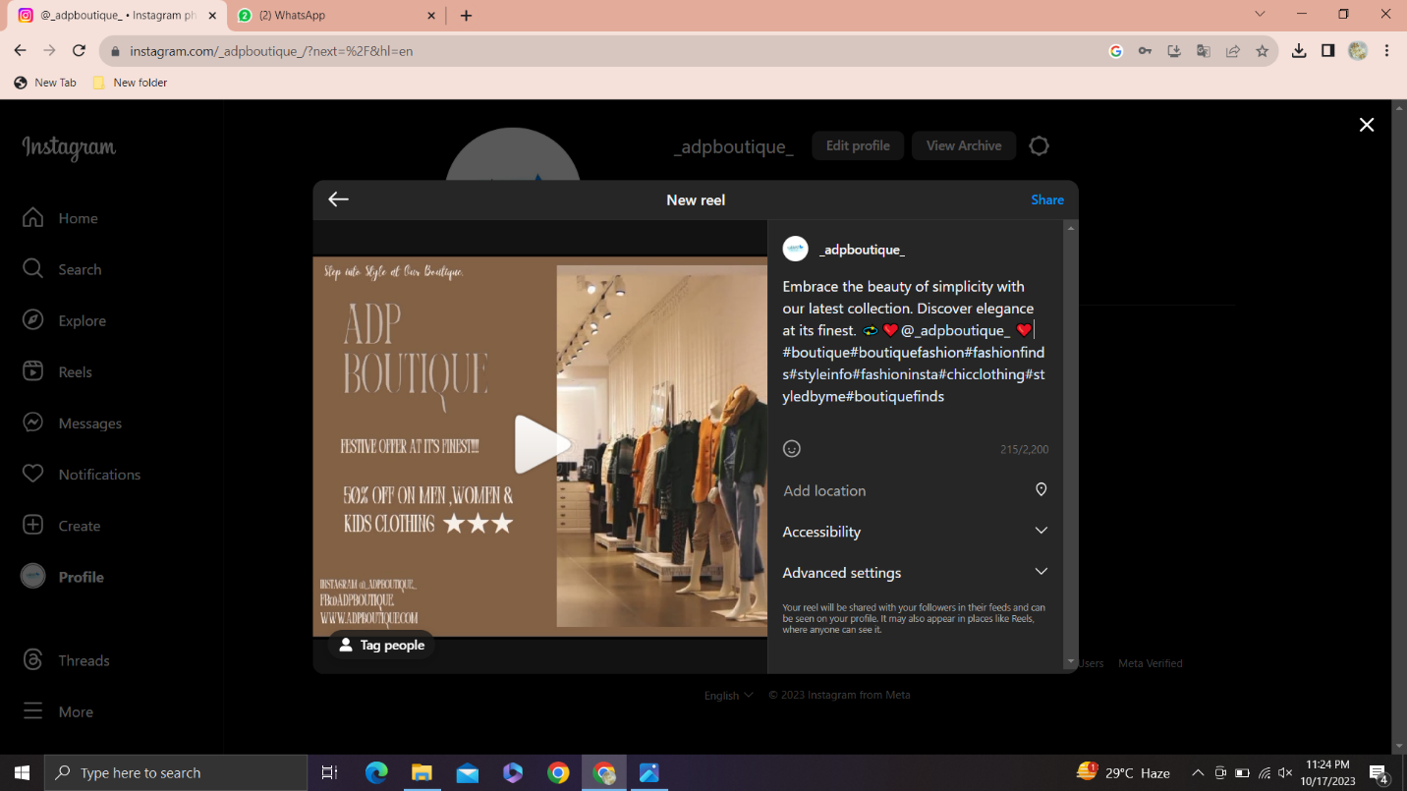

Step 6: Click the boost profile

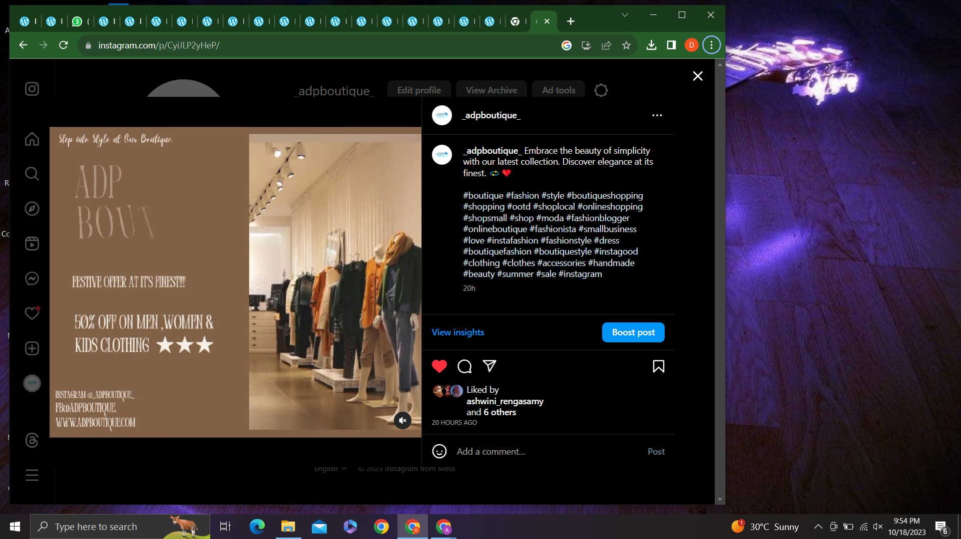

Step 7: Select your targrt

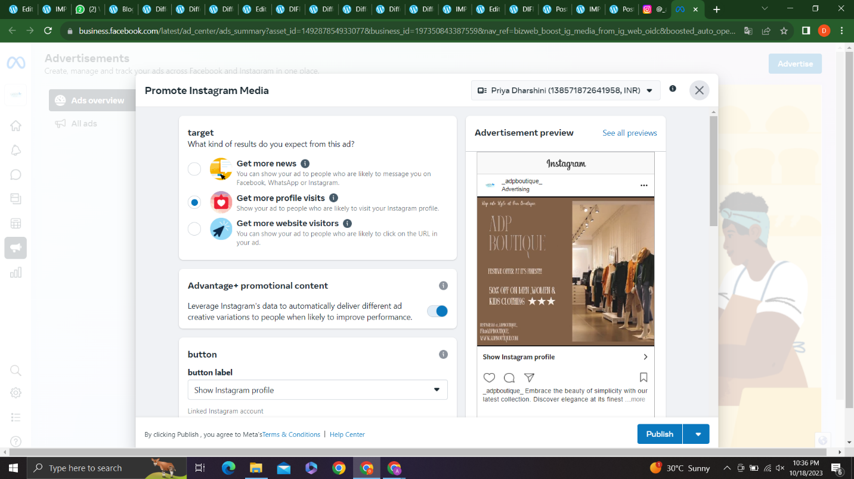

**Step 8: Select visitors:** 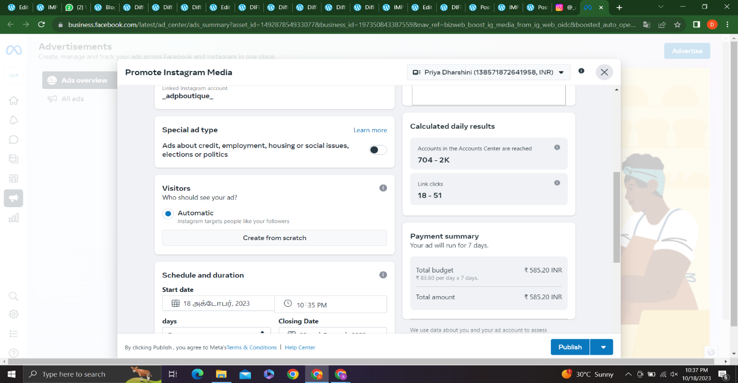

Step 9:select budget and publish

